Tab 1


StoryForge AI Documentation Architecture Guide
This guide outlines the documentation architecture for the StoryForge AI project, integrating the StoryCraft Protocol with the newly proposed Temporal AI framework and the dynamic SOPs directory. This structure ensures clarity across governance, technical contracts, and runtime execution logic.

📄 Core Project Documentation
The following documents form the foundation of the StoryForge AI project, defining its structure and processes:

Doc Name | Description | Role in Protocol
PROTOCOL.md | The "Constitution" of the project. Defines the logic-first workflow and agent orchestration. | Governance
SERVICES.md | The source of truth for all AI service contracts (e.g., generateNarrative, generateImage). Defines inputs, outputs, and models. | Technical Contract
AGENTS.md | A dynamic directory of all in-app creative agents (Master Writer, Songwriter, etc.), including their Base SOPs. | Agent Registry
TODO.md | A live roadmap of development tasks, categorized by priority and phase (e.g., V1.0, V1.1). | Task Management
DEPLOYMENT.md | Technical instructions for Docker builds, Local Dev, and Akash Network deployment. | Infrastructure
README.md | High-level project overview, feature list, and "Getting Started" guide. | Project Entry

🚀 New Proposed Documentation (Temporal AI Integration)
To support the transition to durable execution and resilient long-running tasks via the Temporal AI framework, the following documents are recommended:

- WORKFLOWS.md: Defines the logic for long-running Temporal Workflows (e.g., AutonomousBookWorkflow). It should map high-level user goals to specific sequences of activities.
- RELIABILITY.md: Outlines the retry policies, exponential backoff configurations, and idempotency keys required for resilient AI API interactions.
- STATE_SCHEMA.md: Documents the structure of the "Durable Variables" stored within Temporal, ensuring consistency across worker restarts.

📂 SOPs Folder Connection
As per Directive 2 from the recent After Action Review (AAR), the system has been updated to decouple Standard Operating Procedures (SOPs) from the code bundle.

- Dynamic Loading: The application now fetches and parses files within the SOPs/ folder at runtime.
- Master Writer Frameworks: The SOPs/ folder contains specialized narrative frameworks (e.g., "Angular Momentum," "Hero's Journey") that are appended to the Master Writer's Base SOP during execution.
- Extensibility: New agent behaviors can be added simply by dropping a new .txt or .md file into the SOPs/ directory, which is then automatically recognized by the ProjectContext and service layers.

🛠️ Implementation Guideline
When adding a new feature, developers must adhere to the following documentation workflow:

- Update TODO.md with the task.
- Define the contract in SERVICES.md.
- If it involves a new agent or behavior, add the corresponding SOP to the SOPs/ folder.
- Reference these in AGENTS.md to ensure the UI can dynamically populate the new capabilities.

All documentation files should be reviewed by Person and committed by Date. Additional guidance is available in File.

Tab 2
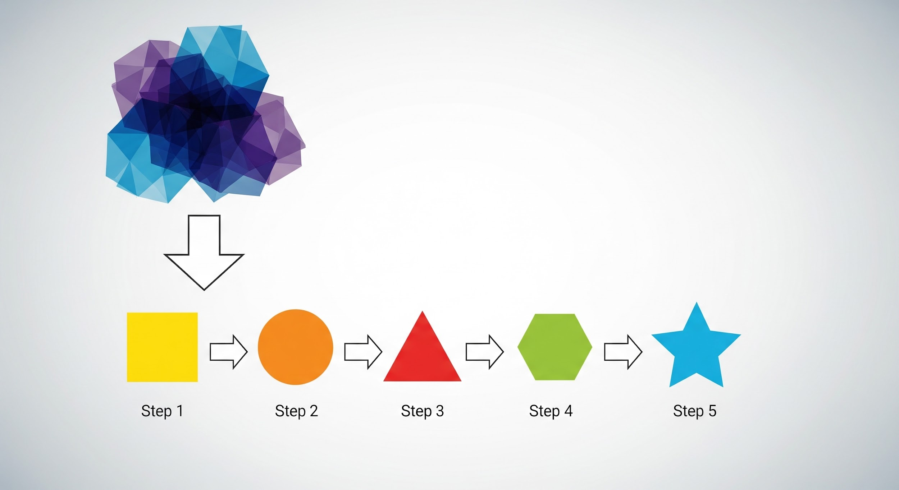

Visual Explainer Skill Integration: Streamlined Architecture
This document outlines the streamlined architectural integration for the new "Visual Explainer" skill across the three core operational documents: SERVICES.md, AGENTS.md, and the SOPs/ directory. This structure adheres to the project's Implementation Guideline by defining the contract, linking the capability to an agent, and detailing the operational logic.

1. Contract Definition (Update to SERVICES.md)
The service contract defines the essential function, inputs, and outputs for the new AI service, serving as the source of truth for the system. This simplified definition ensures clarity for all service consumers.

Service Name | Description | Inputs (Streamlined) | Outputs
generateVisualExplainer | Generates a concise, visual step-by-step explanation of a complex concept. | topic: str | json_prompt: str

2. Agent Linkage (Update to AGENTS.md)
The new skill is registered under the relevant agent, the Master Writer, by defining its specialized SOP file. This registration in AGENTS.md is critical for allowing the UI to dynamically recognize and populate the new capability.

Agent Name | Base SOP Location | New Skill SOPs (Appendable)
Master Writer | SOPs/base_writer.md | visual_explainer.md

3. Operational Logic (New File: SOPs/visual_explainer.md)
This new SOP file contains the precise, logic-first instructions that define the skill's actual intelligence. The content focuses purely on the execution logic that is dynamically loaded and parsed at runtime, ensuring a streamlined operational structure.

# Visual Explainer SOP

**Directive:** You are an expert visual explainer. Given a `topic`, you must break it down into no more than 5 sequential, easy-to-understand steps. Focus on simplicity and clarity.

**Output Format:**
1. Step Title: [Description]
2. Step Title: [Description]
3. Step Title: [Description]
4. Step Title: [Description]
5. Step Title: [Description]

Implementation Checklist
To ensure full integration and adherence to the Documentation Architecture Guide, all documentation files should be reviewed by Person and committed by Date. Additional reference material is located in File.

